Mechanics Conference

Date/Locations:  Tuesday & Wednesday  May 23 & 24, 2017  Holy Cross Energy  3799 Highway 82, Glenwood Springs, CO  Time:  Tues: 9:00am – 4:30pm  Wed: 8:00am – 12:00pm  Fee:  The cost of this course has been paid by the Colorado Electric Educational Institute and the Operations/Engineering education fund.  Lunch and dinner will be provided on Tuesday, May 23, 2017.  To Register:  Contact Jen Hight at the CREA office  (303) 455-2700 ext. 700  or e-mail at jenhight@coloradorea.org  Hotel reservations can be made at the Marriott Courtyard, 105 Wilfsohn Rd, Glenwood Springs. (970) 947-1300. Ask for the CREA rate ($134)  Registration Deadline:  May 5, 2017  A minimum of 10 people must be registered for the course to be held. A letter will be sent to all participants confirming their registration in the course. | Tuesday, May 23, 2017  8:45am Introduction and welcome  Dale Kishbaugh, CREA  9:00am – 11:00am ABS Truck and Trailer  Instructor: Andre Capritta, Meritor  11:00am – 11:15am Break  11:15am – 12:00pm RESAP/Welding Areas Review  Presenter: Angelea Meyer,  Colorado Rural Electric Association  12:00pm – 1:00pm Lunch  1:00pm – 2:00pm Highway and Transportation  Safety Presenter: Trooper Dale Kettle,  Colorado State Patrol  2:00pm – 2:15pm Break  2:15pm – 4:30pm Diesel Aftertreatment Diagnosis  Instructor: Kevin Elliott,  McCandless Trucking  4:30pm Adjourn  6:00pm Dinner,  Glenwood Canyon Brewing Co.  402 7th Street, Glenwood Spgs,  Wednesday, May 24, 2017  8:00am – 10:00am Interfacing with Electronics and  Hydraulics  *Bonus: Gelcoat and Fiberglass  discussion  Instructor: Tim Petrishen, Altec  10:00am – 10:15am Break  10:15am – 12:00pm Roundtable Discussions  12:00pm Adjourn  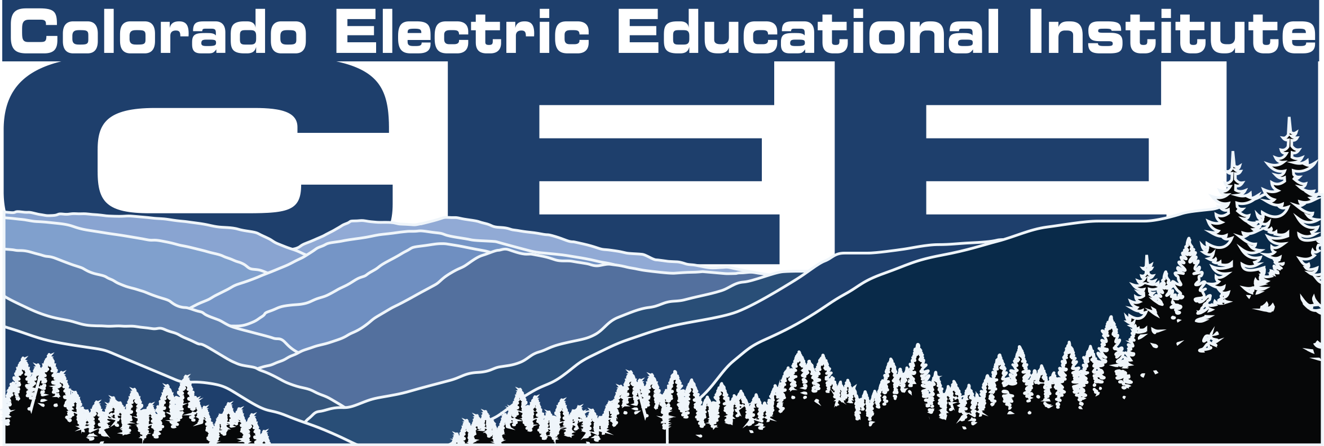  Colorado Rural Electric Association Colorado Electric Educational Institute

